**Opdracht 1**



**tekst??

response

internet

request

server

Client



**Opdracht 2**

https://www.bol.com/nl/p/hoe‐werkt‐dat‐ nou/9200000057347012/?country=BE&suggestionType=browse#product_alternatives

Body

Headers

**Opdracht 7**

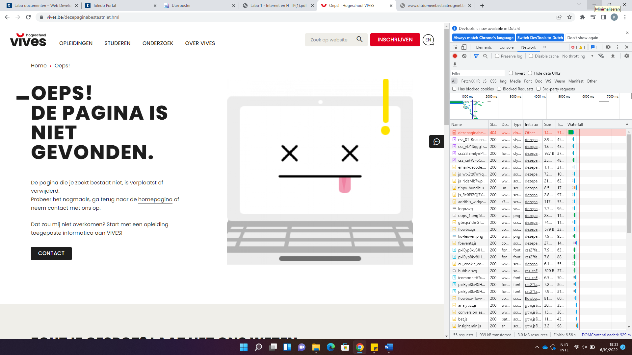

**Opdracht 8**

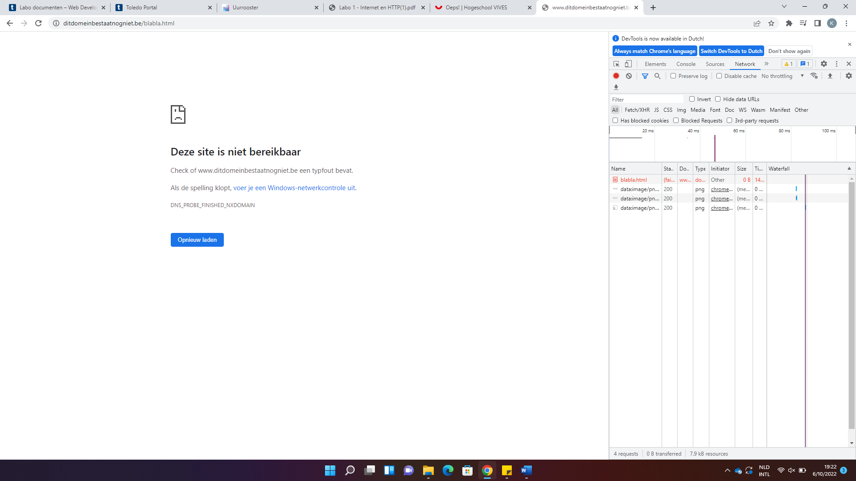

**Opdracht 9**

|  |  |  |  |
| --- | --- | --- | --- |
|  |  |  |  |
| 200 - OK | 301 – Moved Permanently | 400 – Bad request | 500 – Internal server error |
| 204 – No Content | 302 – Found (Moved temporarily) | 401 - Unauthorized | 503 – Service Unavailable |
|  | 303 | 404 |  |

**Opdracht 10**

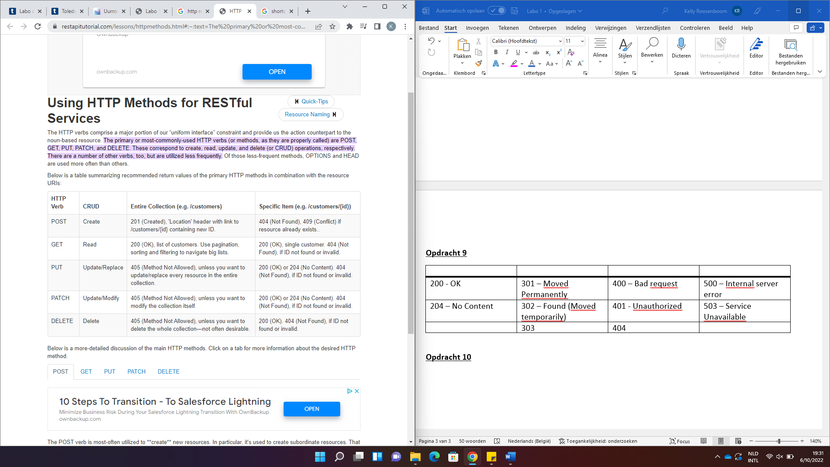

**Opdracht 11**

??

**Opdracht 12**

**Opdracht 13**

* Nieuwsblad -> 12
* Cnn -> 9
* Vives -> 9
* Vrt -> 8